**Iteration 1 Report**

**Customer Meeting**

Date: 10/23

Time: 19:00 - 20:30

Place: HRBB 104

**Meeting Video**

<https://drive.google.com/open?id=12st7mgVa_R-O439tmrL_M2usNaIyWaQR>

**User Stories**

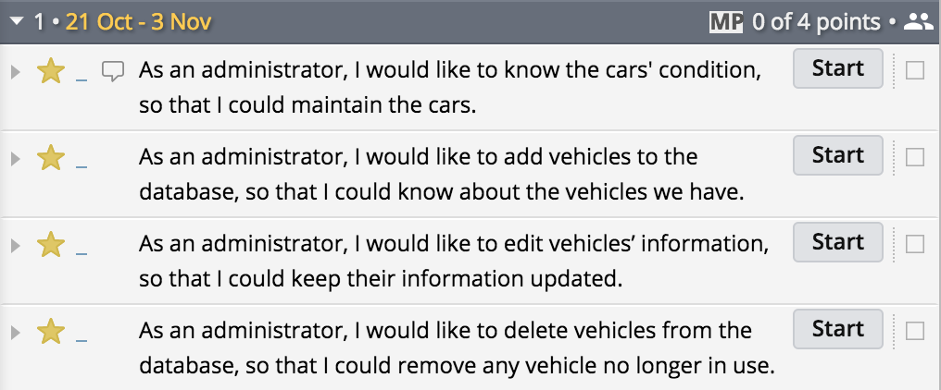

**Design Diagram**

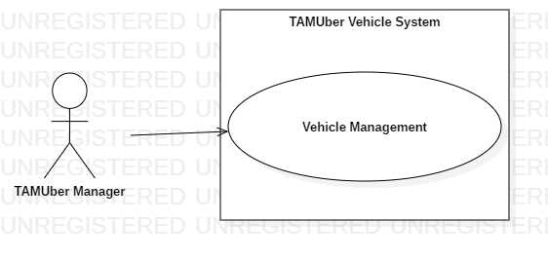

**Evaluations of Code and Tests**

rspec:

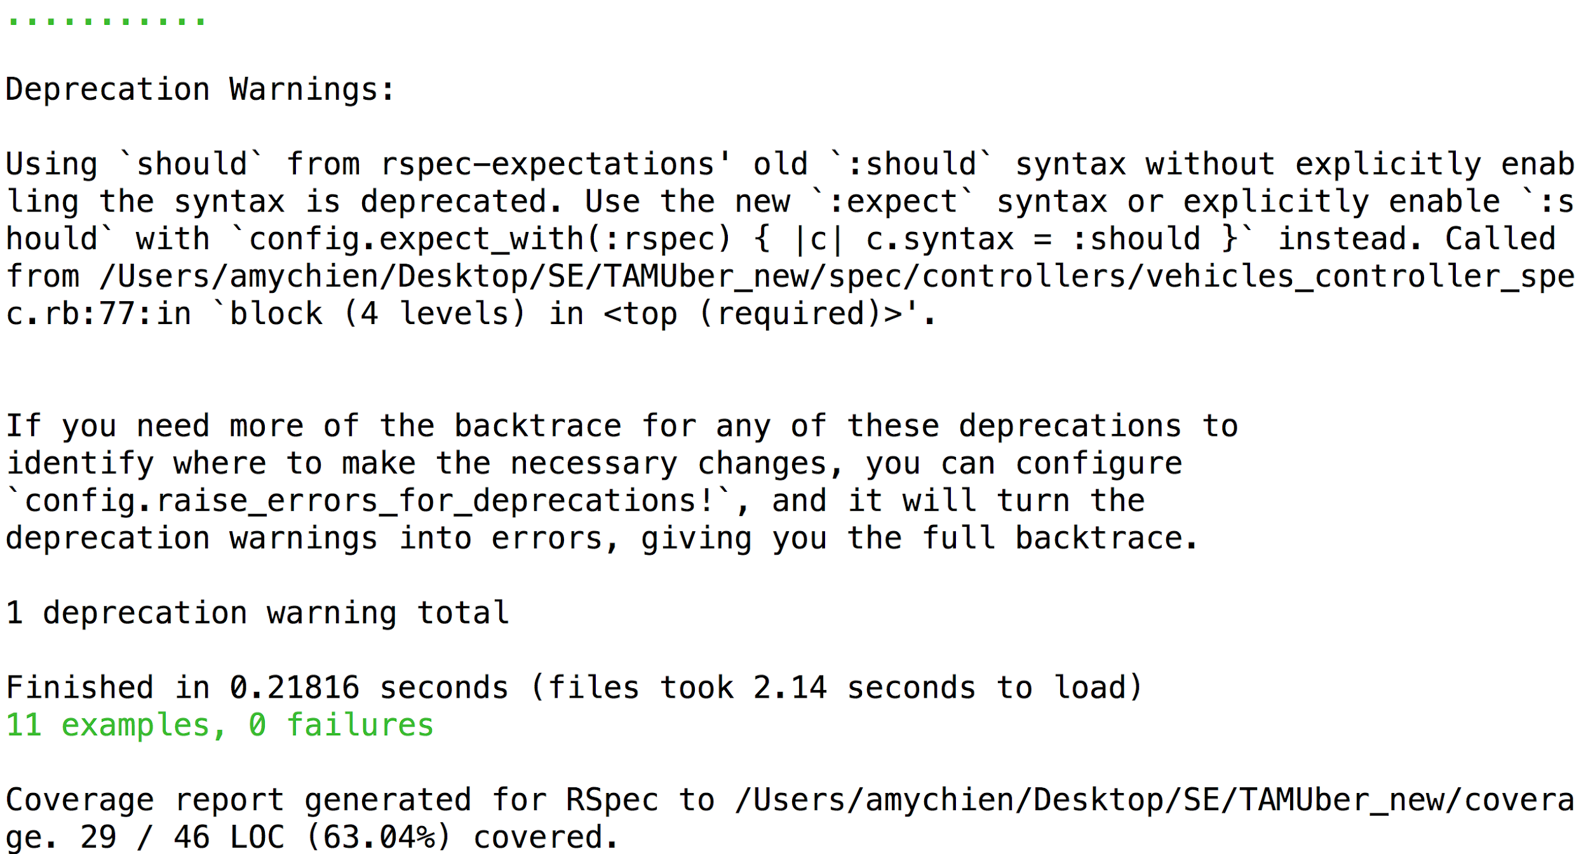

**Pivotal Tracker**

<https://www.pivotaltracker.com/n/projects/2205674>

**Github Repo**

<https://github.com/ShaoEnChen/TAMUber>

**Heroku**

<https://tamu-uber.herokuapp.com/>